**ASSIGNMENTS ON DIGITAL MARKETING**

**NAME: ABINASH** R

**DEPARTMENT:** BE COMPUTER SCIENCE AND ENGINEERING

**COLLEGE:** 8151 DHANALAKSHMI SRINIVASAN INSTITUTE OF

TECHNOLOGY

**NAANMUDHALVAN COURSE**: DIGITAL MARKETING

**NM ID: 320170D0F00AB679E14B5D5B064FC9B**

**ASSIGNMENT 1:**

Create a blog or website using Blogspot and WordPress. Customize

The theme design and post new article with 500 words.

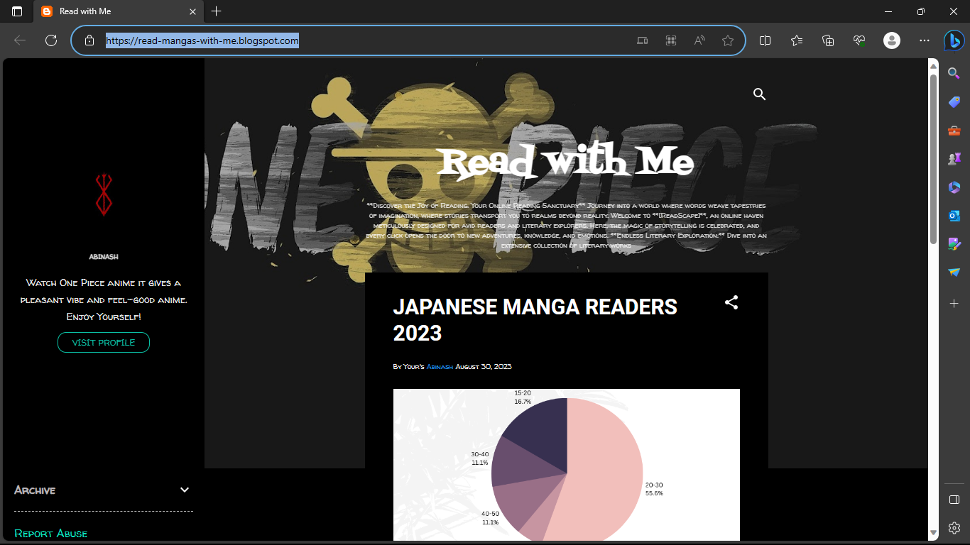

<https://read-mangas-with-me.blogspot.com/>

**ASSIGNMENT 2:**

Create a new Facebook business Page and Post one social media poster for your brand.

<https://www.facebook.com/profile.php?id=61552728231658&sk=photos>

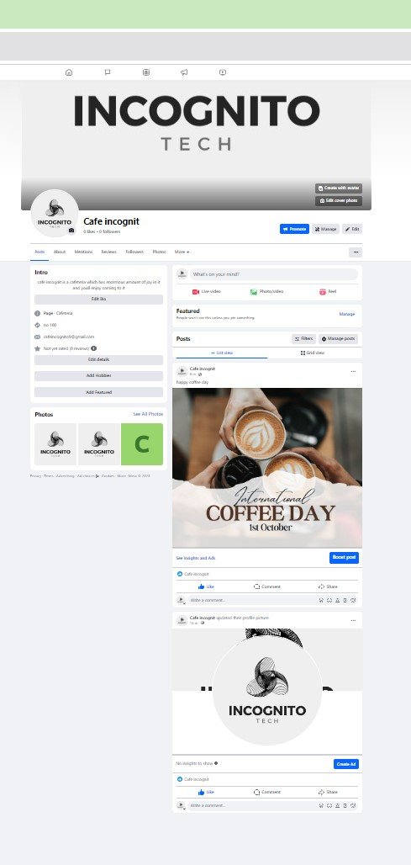

**ASSIGNMENT 3:**

Create and design a social media advertisement poster using Canva.

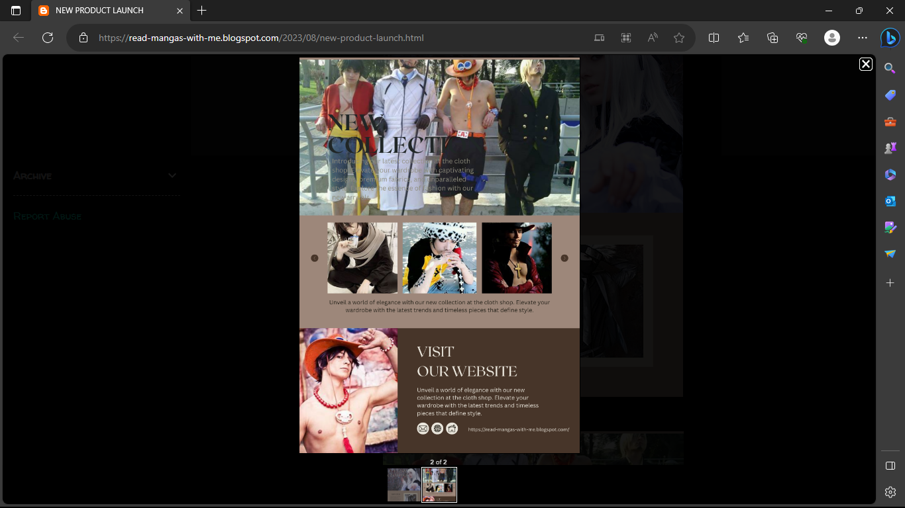

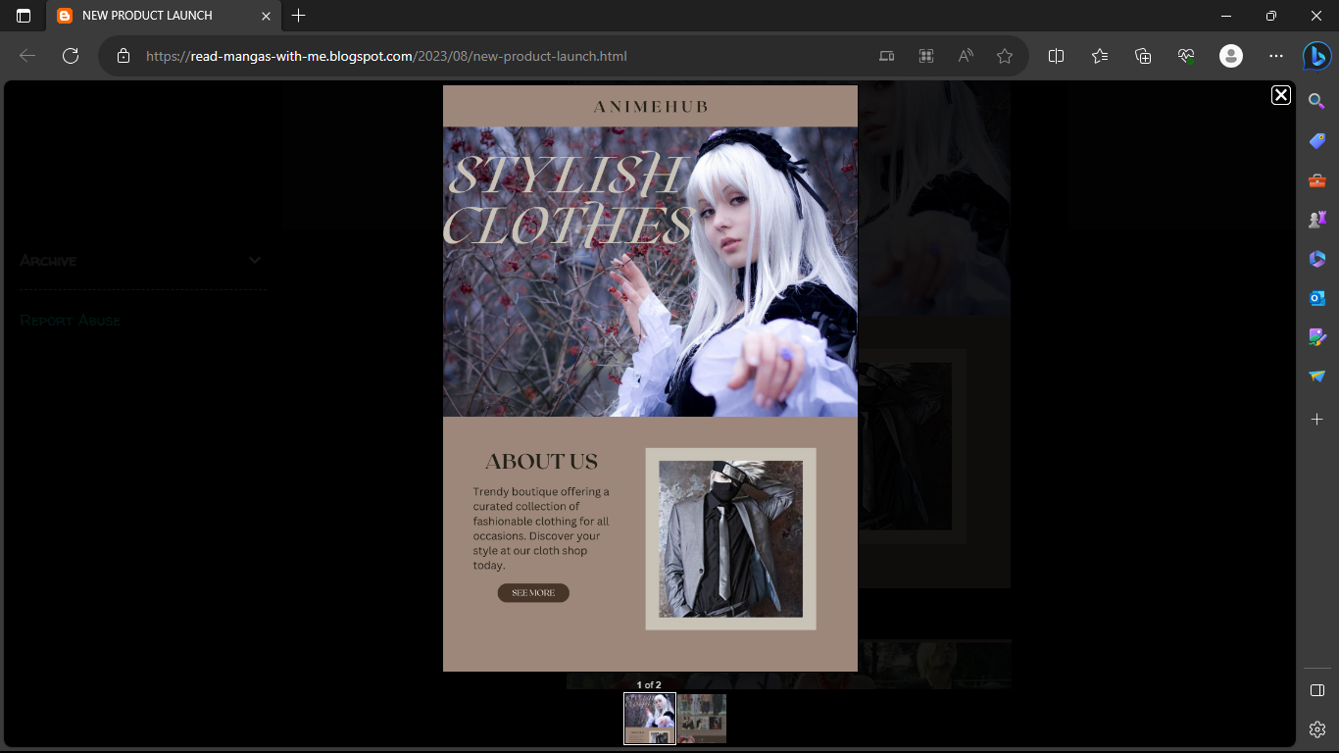

**ASSIGNMENT 4:**

4.Create email newsletter design using MailChimp or Canva tool.

[NEW PRODUCT LAUNCH (read-mangas-with-me.blogspot.com)](https://read-mangas-with-me.blogspot.com/2023/08/new-product-launch.html)

